**General Integrated Science Unit 3**

**Task : Mine Rehabilitation**

**Assessment Type : Extended Response**

**Weighting : 7.5%**

**Time allowed for the task:**

* 1 week to research the topic and complete your ***notes*** at school and home as far as possible.
* Field visit to KCGM to learn how KCGM rehabilitate the land after mining. Then one more day to complete notes before handing them in.

**How the mining industry carries out rehabilitation of land:**

The mining industry is the main contributor to the economy of Western Australia and Australia as a whole. However the environmental impact of mining the landscape is massive and its effect on the ecosystem is often unmeasurable. The government is trying to make companies accountable for their environmental footprint but often the cost or the feasibility is too much for anything substantial to be done.

KCGM is having a major impact on the environment of the goldfields both economically and environmentally. However due to their extensive rehabilitation program the company is taking measure to reduce their environmental footprint.

**Elements of the task:**

**Part A. Create a set of notes on the following questions using your own research and the information from the field trip. 50% of final mark**

1. How much money does Western Australia make from the mining industry approximately and how many people does it employ? *(1 mark)*
2. What are the main minerals mined for in Western Australia? *(2 marks)*
3. What are the main environmental issues that arise with large scale open pit mining such as the Super Pit? *(3 marks)*
4. What is KCGM’s environmental responsibility to **all** groups within the community during mining **and** after the pit closes? *(7 marks)*
5. Information and data is needed to make decisions about how rehabilitation needs to be done. Where does this information come from? *(2 marks)*
6. What is a waste rock dump and how are they used at KCGM? *(3 marks)*
7. What factors have to be considered when creating a design for the waste dump? *(3 marks)*
8. What kinds of tests are carried out to collect the information needed to build the waste dump and then rehabilitate it? *(4 marks)*
9. Once the waste dump has been created, what are the next steps to be carried out to start the rehabilitation of the land? *(4 marks)*
10. Once the final steps have been complete, why is constant monitoring of the waste dump carried out?

*(2 marks)*

1. Have all the rehabilitation projects undertaken at KCGM been successful? Give an example.

*(2 marks)*

1. Why is the waste rock not put back where it came from? *(1 mark)*

**Part B. Field Trip (34 marks) 50% of final mark**

* These will be handed in the next lesson after the field trip.

|  |  |
| --- | --- |
| **Requirements for assessment** | **Due dates** |
| * Your draft research notes completed at home | **30th May** |
| * Your completed research notes and Super Pit tour booklet | **3rd June** |

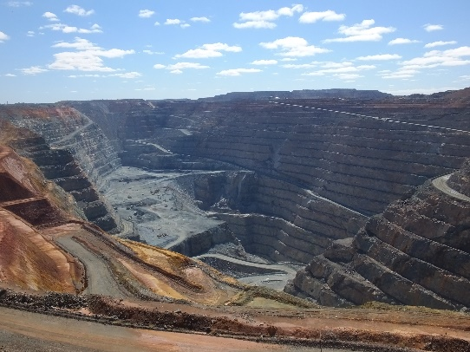During the field trip you will stop at various spots that will show you different aspects of rehabilitation being carried out by KCGM or that have been carried out.

The rules governing rehabilitation are continually changing and what was deemed correct 5-10 years ago may now not correct anymore. With the advances in technology more information has been gained about the environment and this has also lead to changes in the thinking about how rehabilitation should be done.

**Stop 1**

**Superpit lookout – oxide dump and construction of waste rock dump**

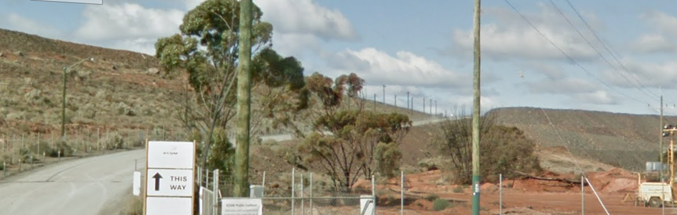

1. How deep is the pit currently?
2. Can the pit be dug any deeper?

_____________________________________________________________________________________________________________________________________________________________________________________________________________________________________________

1. Can the pit be filled in once mining has finished?

___________________________________________________________________________________________________________________________________________________________________________________________________________________________________________________________________________________________________________________________________________________________________________________________________________

1. How do the workers know where to blast and where to dig?

_______________________________________________________________________________ ______________________________________________________________________________________________________________________________________________________________

1. Why are the dump trucks coming from the Morrison starter pit taking different routes when they are full of rock?

_____________________________________________________________________________________________________________________________________________________________________________________________________________________________________________

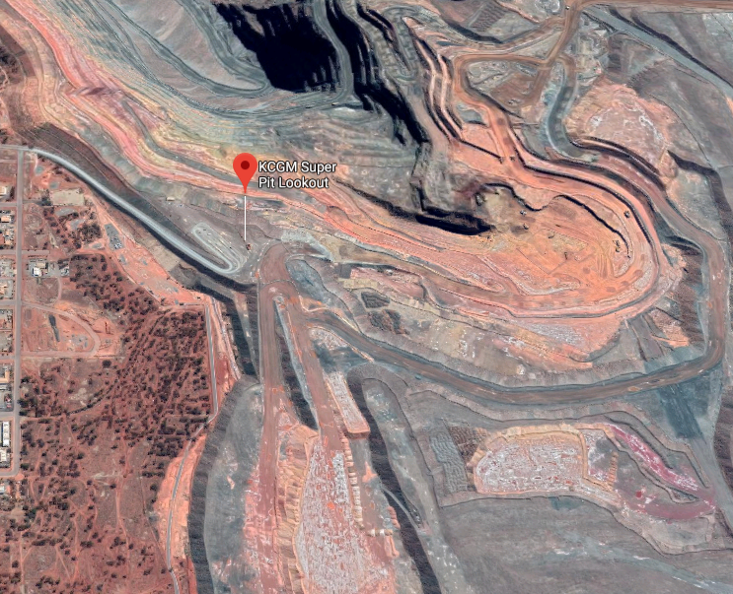

1. What is the difference between oxide and waste rock?

_____________________________

_____________________________

_____________________________

_____________________________

_____________________________

_____________________________

_____________________________

_____________________________

_____________________________

1. Why does material like oxide have to be covered with so much waste rock?

___________________________________________________________________________________________________________________________________________________________________________________________________________________________________________________________________________________________________________________________________________________________________________________________________________

1. When the oxide has been covered with waste rock what is the next step in rehabilitation?

___________________________________________________________________________________________________________________________________________________________________________________________________________________________________________________________________________________________________________________________________________________________________________________________________________

1. When does seeding take place?

______________________________________________________________________________________________________________________________________________________________

1. How is it done and why do they do it?

______________________________________________________________________________________________________________________________________________________________

**Stop 2**

**Great Eastern Highway- Croesus Noise Bund Corner successful rehabilitation**

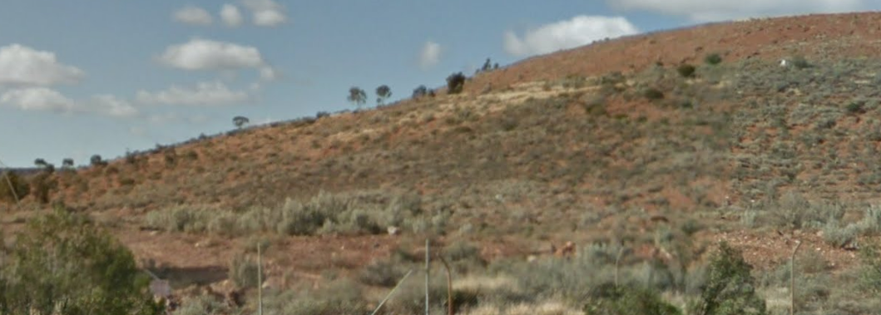

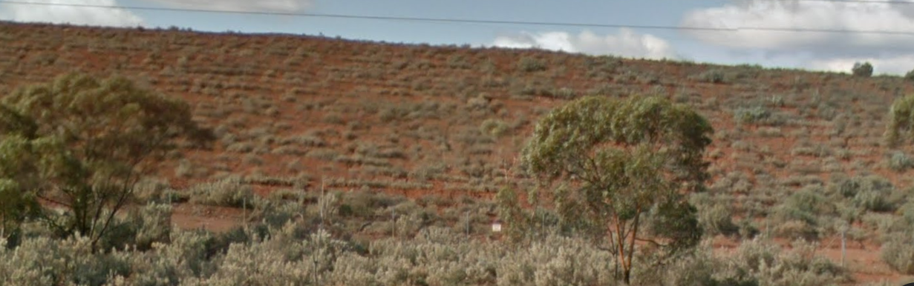

1. What is the point of the waste rock dump along the edge of the Great Eastern Highway?

_____________________________________________________________________________________________________________________________________________________________________________________________________________________________________________

1. Why is it unusual to get such good vegetation growth on this shaped waste dump pile?

_____________________________________________________________________________________________________________________________________________________________________________________________________________________________________________

1. In this kind of environment how long does it take for plants grow to a significant height (to see if the rehabilitation is working?

_____________________________________________________________________________________________________________________________________________________________________________________________________________________________________________

**Stop 3**

**Boorara Road- Croesus Noise Bund, oldest rehabilitation**

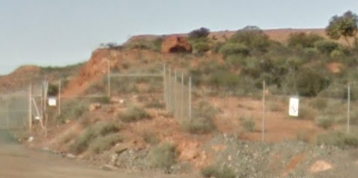

1. State the difference between this style of rehabilitation and the ones down Black Road and Bulong Road.

________________________________________________________________________________________________________________________________________________________________________________________________________________________________________________________________________________________________________________________________________________________________________________________________________________________________________________________________________________________________________________________________________________________________________________________________________________________________________________________

1. Why have they changed the way things are done?

_____________________________________________________________________________________________________________________________________________________________________________________________________________________________________________

1. Why are material properties important when deciding how to dump waste rock initially before rehabilitation?

__________________________________________________________________________________________________________________________________________________________________________________________________________________________________________________________________________________________________________________________________________________________________________________________________________________________________________________________________________________________

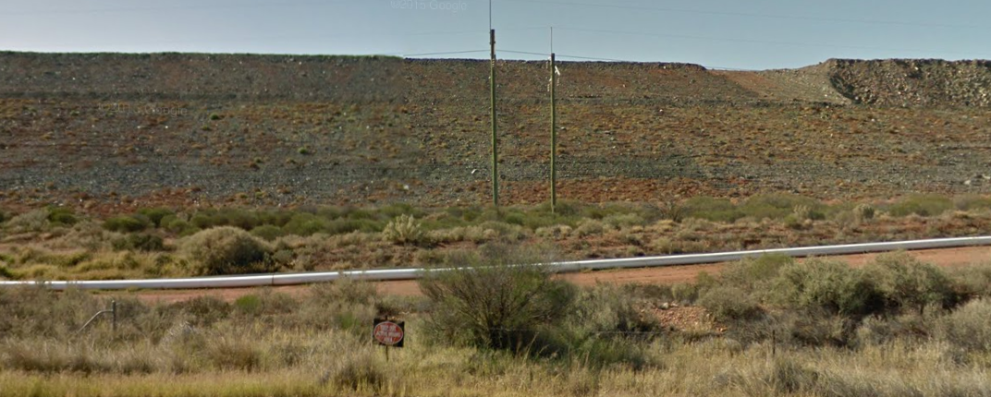**Stop 4 Black Street – Northern Rehabilitation**

1. When was this site rehabilitated?
2. How was the rehabilitation carried out?

___________________________________________________________________________________________________________________________________________________________________________________________________________________________________________________________________________________________________________________________________________________________________________________________________________

1. Where did the rock come from that made the pile?

______________________________________________________________________________________________________________________________________________________________

1. Where did the soil come from that the plants are growing in?

______________________________________________________________________________________________________________________________________________________________

1. Why is the success of the rehabilitation difficult to establish?

_____________________________________________________________________________________________________________________________________________________________________________________________________________________________________________

1. What was learnt from this rehabilitation and how were things changed?

_____________________________________________________________________________________________________________________________________________________________________________________________________________________________________________

_____________________________________________________________________________________________________________________________________________________________________________________________________________________________________________

**Stop 5**

**Black Street/Bulong Road – Northern Dump Rehabilitation**

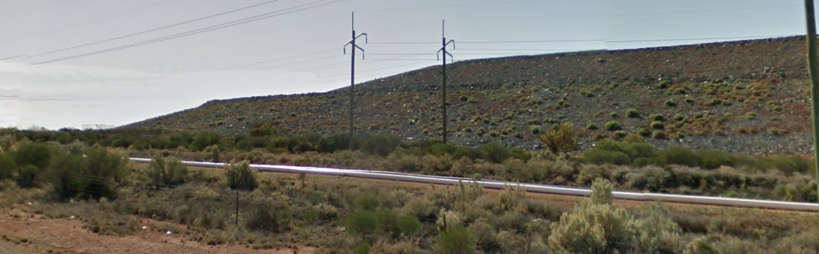

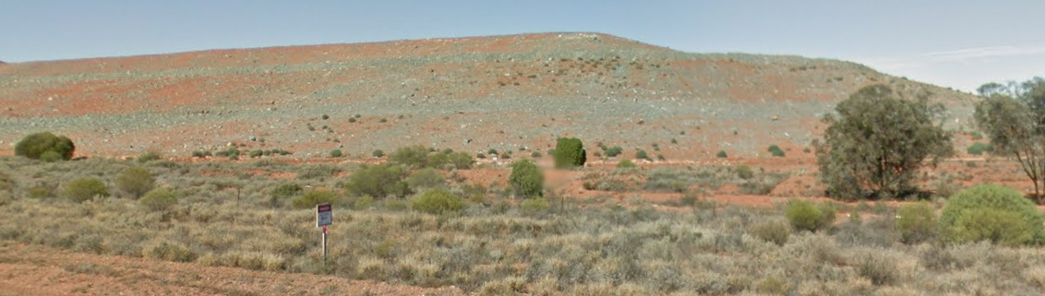

1. When was this waste rock dump rehabilitated?
2. How can you tell if it has been more successful than the previous one?

_____________________________________________________________________________________________________________________________________________________________________________________________________________________________________________

1. What things have been changed and have they worked?

_____________________________________________________________________________________________________________________________________________________________________________________________________________________________________________

_____________________________________________________________________________________________________________________________________________________________________________________________________________________________________________

**Stop 6**

**Bulong Road – Tailings Dam Trial Rehabilitation**

1. Why has only a small amount of ground been rehabilitated?

_____________________________________________________________________________________________________________________________________________________________________________________________________________________________________________

1. What tests are being carried and why are they being done?

__________________________________________________________________________________________________________________________________________________________________________________________________________________________________________________________________________________________________________________________________________________________________________________________________________________________________________________________________________________________

1. Is this normal practise? Why are the tests carried out?

__________________________________________________________________________________________________________________________________________________________________________________________________________________________________________________________________________________________________________________________________________________________________________________________________________________________________________________________________________________________

**Stop 7**

**Bulong Road – waste rock dump prior to levelling/changing angle**

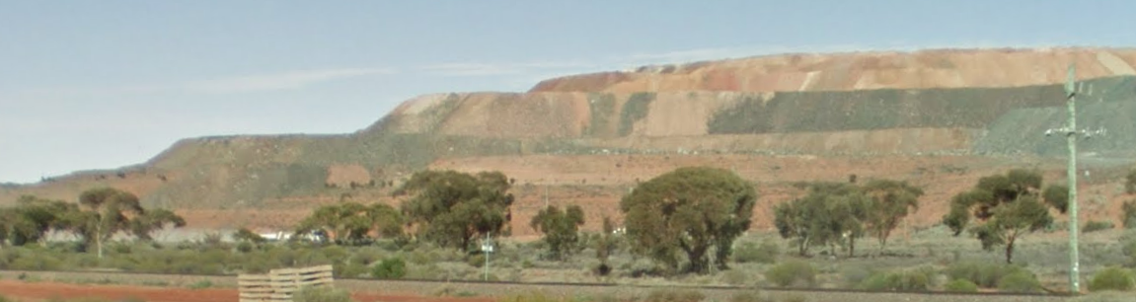

1. What angle is the waste rock dumped at?
2. What information determines how much rock can be dumped and at what angle?

__________________________________________________________________________________________________________________________________________________________________________________________________________________________________________________________________________________________________________________________________________________________________________________________________________________________________________________________________________________________

1. Is the pile all waste rock?

_____________________________________________________________________________________________________________________________________________________________________________________________________________________________________________

1. Why is the angle of the waste rock changed when it is going to be rehabilitated?

___________________________________________________________________________________________________________________________________________________________________________________________________________________________________________________________________________________________________________________________________________________________________________________________________________

**Stop 8**

**Bulong Road – tailing dump**

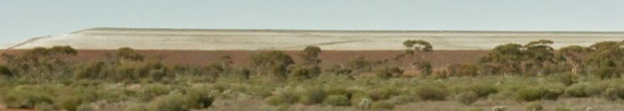

1. What is a tailings dam? How is it different to a waste rock dump?

__________________________________________________________________________________________________________________________________________________________________________________________________________________________________________________________________________________________________________________________________________________________________________________________________________________________________________________________________________________________

1. Why is there water in the tailings dam and what happens to it?

____________________________________________________________________________________________________________________________________________________________________________________________________________________________________________________________________________________________________________________________

**Stop 9**

**Lookout inside KCGM.**

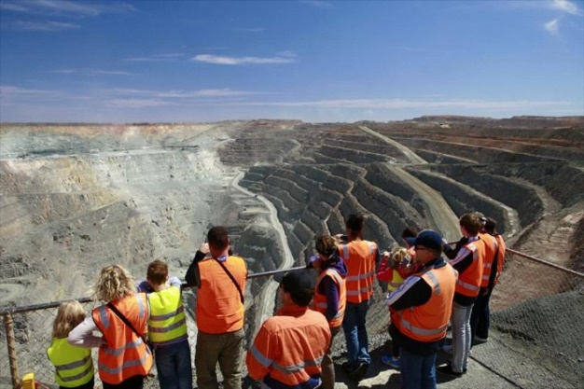From here you can see the design of the pit and the various routes the trucks take.

List any questions you have to ask whilst at the lookout.